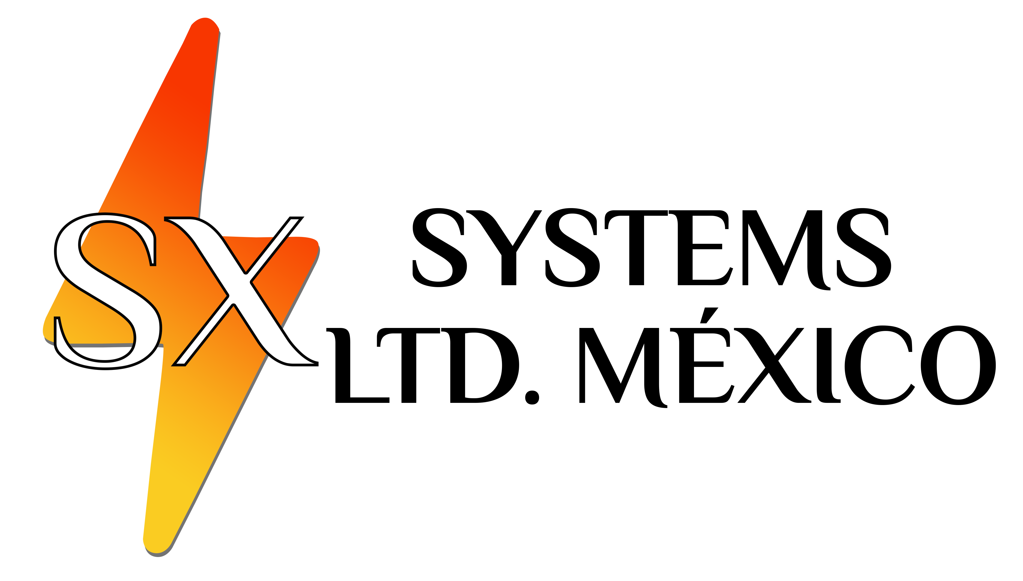
TOP-SEAL BLACK
TM
Surface Coating for Unpaved Roads
PAVED & UNPAVED ROADWAYS –DRIVEWAYS –PARKING LOTS –AIRFIELDS

Cost-Effective Alternative to Asphalt Roads

TOP-SEAL BLACK (TSB) ™ is an environmentally safe, non-petroleum based surface coating and cold in-place recycling additive for paved and unpaved roads, parking lots, and airfields. When properly applied in sufficient quantities, a completed application with TSB will closely resemble an asphalt wearing surface at only a fraction of the cost.
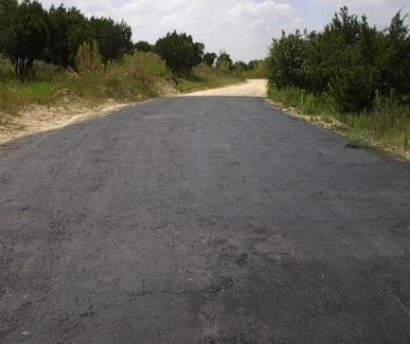
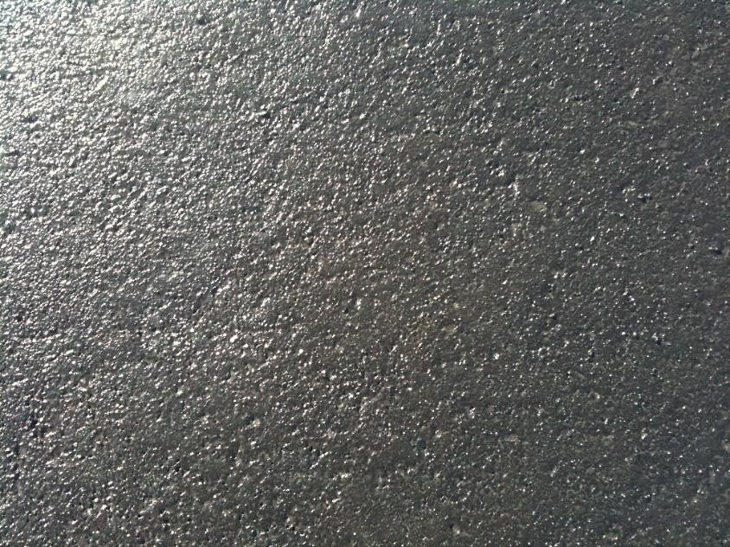
Top-Seal Black application in Central Texas, USA

TSB was invented at the University of Texas at Austin, USA. It is patented by the university and solely licensed to SX Systems LTD, México. The product is uniquely adapted to a market in which there are very limited options for cost-effective alternatives to an asphalt wearing surface.
TSB’s performance is maximized when used in combination with its sister product, Top-Seal White (TSW) Liquid Soil Sealant and Stabilizer. As a highly effective liquid base stabilizer, Top-Seal White’s proven capacity for dramatic improvement of soil strength and impermeability makes it a foundationally perfect match for TSB applications. Please contact SX Systems LTD, México for more information on TSW.
TSB is the premier product of choice when an asphalt wearing surface cannot be afforded or is simply not needed for low-volume traffic environments. In its applied and cured state, TSB has a unique resemblance to asphalt and typically cannot be distinguished from it by the average person.
TSB is easy to use. There are no special equipment or handling procedures for using the product. Simply dilute TSB with water in a holding tank and distribute over the area of coverage. TSB is an excellent choice significant improvement of unpaved and recycled roads. Contact SX Systems LTD, México for more information on TSB.

For More Information on Top-Seal Black ™ and SX Systems LTD, México business opportunities, contact:

SX Systems LTD, México
University of Texas Technology Commercialized Company 94Miguel Leandro Guerra #181-B Colonia Centro C.P. 47400
Phone: (52) 474 742 1030 y (52) 474 742 1031
Copyright © 2014 SX Systems LTD, México All rights reserved

